1. Nearest Areas option a - Area Types add er option korte hobe

1. ⁠Velocity Realtor Company Brochure add korar jaiga ta “Site configuration” a korte hobe.

1. Send your Requirements and Requirements both are same linked but in the Section “Send your Requirements” there is missing a option “Enquiry From” ( Agent, Owner, Individua

1. Interior page contact details gulo change korte hobe. Admin a change korar option thakbe.

1. Admin a Developers option Developer Details entry korleo Home page a seta show korche na.

1. Project a customer review ta vertically show hochhe, ota horizontally hobe.

1. Floor Plan Show er option ta as uer uploaded image er size a show hochhe. & Get Access ki vabe kaj korbe…..????

1. Project er Admin section a Marketing and Promotion Option er home page er songe connectivity thik korte hobe.

1. Mobile Vertion a Side moving arrow ta asche na. and side a skide kole project slide shake hochhe.

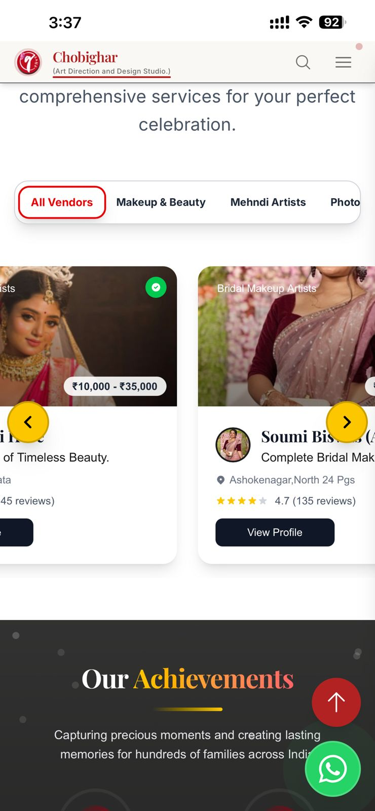

1. Project Status er options gulo:
2. Ready to Move
3. Under Construction
4. Upcoming Project
5. Possession Soon
6. Sold Out
7. New Launched

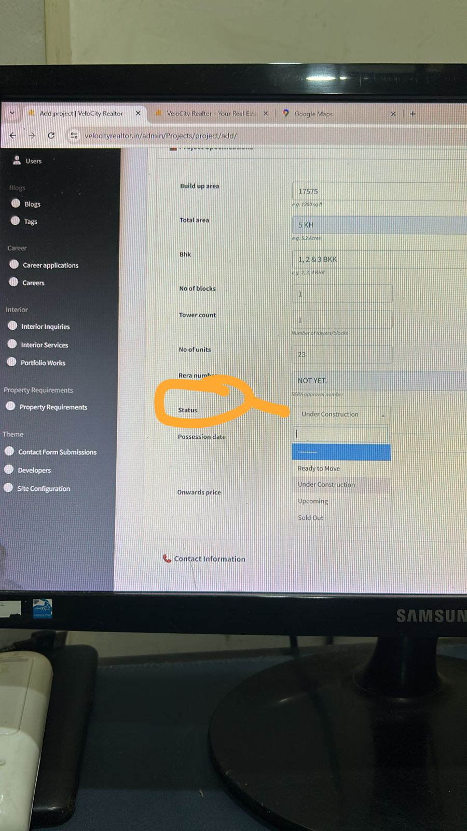

1. Project er visibility position er serial no ta put korar jaiga nei. Jeta last Enlist hochhe seta first a show korche. Setar theke better serial no deoa gele. Because client er package hisabe amra position debo.
2. Floor Plan Access Option is not working. Get Access a click kole “Quick Enquiry” te connect hochhe. Seta holeo ok. But I think POP UP form screen a asbe and then submit kole Floor plan Show korbe seta better. Like Somani..

1. Kono Project a “Schedule Appointment” A click kole “Quick Enquary” form a connect hochhe , But okhane Date and time Sellect er kono options nei.

Send Inquiry korle ei error ta asche.

1. This Call Us Now Button on the Home Page relates to another Mobile No. that is – 9876543210.

1. Client Testimonials Reviews are from Different locations, and the Names are all non-Bengali names, and it has no access from admin panel. We need its Access In Admin To make it More Authentic Review.

1. The Amount is showing in full digits on the Floor Plan Section, which should show like Short Digit like Onward Setion.

